5.106: (a) To find find the maximum height and time to the top without fluid resistance:
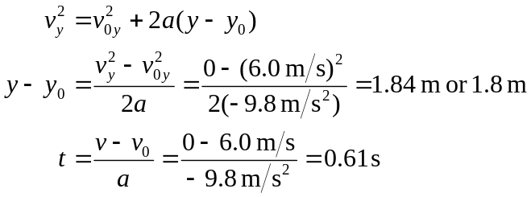
(b) Starting from Newton’s Second Law for this situation
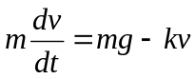
we rearrange and integrate, taking downward as positive as in the text and noting that the velocity at the top of the rock’s “flight” is zero:
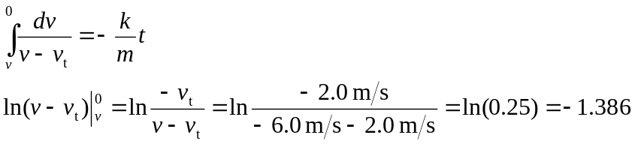
From Eq. 5.9, and to the top. Equation 5.10 in the text gives us
